WEB SCREPTING

ASSIGNMENT: 09/09/25

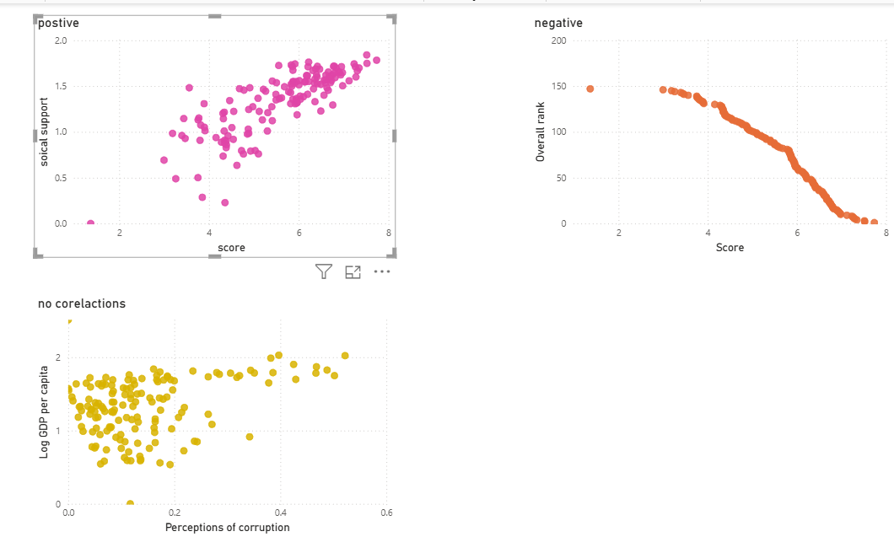

Steps to reproduce:

1. Visualizations:

* Go to build visual
* Then selected the scatter chart to represent
* First scatter chart: X-axis = score and y-axis= social support
* It is showing a positive response
* Second scatter chart: x-axis = score and y-axis = overall rank
* It is showing a negative response
* Third scatter chart: x-axis = perceptions of corruption and y-axis = GDP per capita
* It is showing no correlation response

1. Go to Format visual

* Click on visual
* Go to markers: select color
* Change the color of the scatter chart
* In color, u go for conditional formatting, which is represented by (FX)

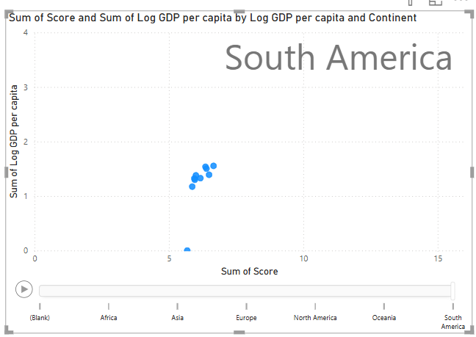

Steps to reproduce:

1. Go to visualisation

* Build visual
* Pass values = GDP per capita , x-axis = sum of score,

y-axis = sum GDP per capita and play axis = continent